**Mixed-Design ANOVA**

* Explain the advantages and challenges of using a mixed design

It’s most flexible- you can combine between and within subject conditions

-gives you a little more explanatory power

-RMxSub is the denominator in this term which gives you more power than fully between

It isn’t as powerful as a fully within design but it is more powerful than fully between

Order effects, Counter balance, Fatigue

Homogeneity of Covariance (within the repeated factor) is an extra assumption= are the covariances from group 1 to group 2 consistent

* **Explain in both words and visually the difference in error term of the mixed design to the repeated and independent ANOVA.**

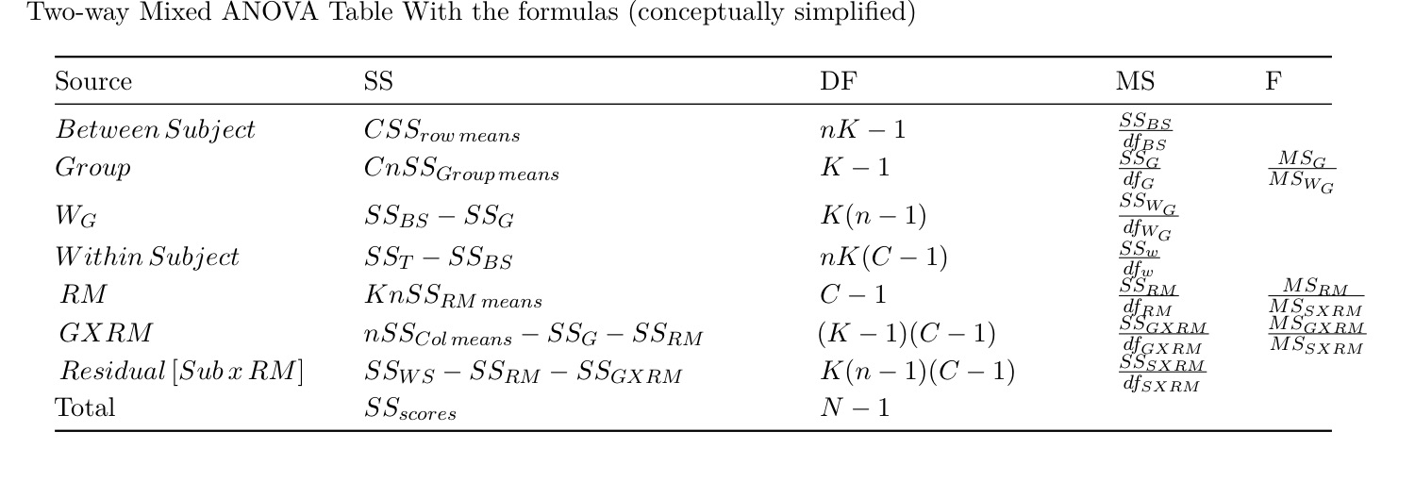

The Fully Within design accounts for the most error and therefore is the most powerful

The Fully Between design only has the W error term and is the least powerful

The Mixed design has a residual error term in addition to the W, which accounts for the interaction between the subject variance and the repeated measure variance

* What are the assumptions of the Mixed ANOVA?
  + How are these assumptions the same and different from the Independent and RM ANOVA?

Box’s M: We have a covariance matrix for each group and we assume that the variance within each group is equal to the other (HOCV)

* + How do we test for them?
  + How do we adjust for them if they are violated?
    - Explain what is currently done “in the wild” versus what the book suggests do when you violate boxes M.

People who want to see the interaction will still use the ANOVA and then ideally will follow up with a t-test

* + - * Speculate as to why this assumption is ignored in the wild (in other words what are the advantages to ignoring it), but what are the dangers in ignoring it.
        + Connect this to replicability failures in the field
* Explain the methods to follow up a mixed ANOVA
  + Describe the difference between planned and unplanned comparisons relative to each possible route and relative to each assumption violated [Basically be able to explain you the logic and rational for your decision trees]

**Bootstrapping**

* What is the goal of resampling methodologies?

Resampling methods are used to estimate the underlying distribution and error terms

They are a work-around to classical assumptions for generating p-values and confidence intervals

They allow you to directly assess the differences between medians, variances, constructed indexes

* What are the underlying procedures of the jackknife technique?

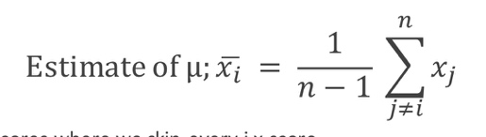

You recalculate the mean for a set of scores by skipping every j score

This allows you to have sampling without replacement

It is biased towards normal distributions, so if your data is non-normal it will move the measurements closer to the mean

* What are the underlying procedures of the bootstrap technique?

Sampling with replacement

* + Why did the bootstrap succeed where the jackknife failed?

You sample without replacement so it isn’t able to calculate everything like median and confidence intervals

* What are benefits and disadvantages of bootstrapping?
  + Why do we say garbage in and garbage out?

If the data are bad or the model is bad then bad things come out. You can’t fix bad data with a good model and you can’t fix a bod model with good data.

* How is the standard error calculated from a bootstrapped sample?

SE is the SD of the bootstrapped distribution

* Why are bootstrap confidence intervals “better” than classical confidence intervals?

They’re better because they allow for the data to be non-symmetrical

You can get confidence intervals of literally any type of statistic

* + Explain the four types of confidence intervals that can be created from the bootstrap method.

Type 1: similar to z test, produces symmetrical confidence intervals, worst type

Type 2: a bootstrapped students t test, produces symmetrical confidence intervals, not good

Type 3: takes a bootstrapped distribution and calculated the percentiles, produces non-symmetrical confidence intervals, better than types 1, and 2

Type 4: takes a bootstrapped distribution and calculated the percentiles, correct the bias of the distribution by using the jackknife, produces non-symmetrical confidence intervals, this is the best type If correction is available

**Non-parametrics**

* What does it mean when we say a test is nonparametric?

It doesn’t rely on the assumptions of a normal distribution

* What are the benefits and disadvantages of using the nonparametric equivalent of parametric tests?
  + Explain situations in when the nonparametric test can help salvage a data set that parametric testing failed at finding difference.
* What type of data is best suited for parametric versus nonparametric testing?

Nominal data for nonparametric

* Explain the difference between the one-way and two-way chi-square
  + Be able to calculate them and explain the results.

One-way: Goodness of Fit; asks whether the relative frequencies observed in the categories of a sample are in agreement with frequencies in the population; Basically, “Is what we’re seeing different from normal/baseline”

Two-way: Test of Independence; compares the observed frequencies with the frequencies we would expect if there were no relationship between the two variables; Basically, “Are the two variables independent or does knowledge of one variable tell you something about the other”

* Explain how the two-way chi-square is similar to an interaction term in an ANOVA
  + It tests the interaction but you can’t follow it up, high type 2

**Make an ANOVA into a Chi Sq:**

* Sign test: change the data into pos or neg (coin flip)
* Make a threshold and change the data into higher or lower than threshold

**What you should be able to do:**

1. Calculate a Mixed ANOVA.
   1. Be able to select and implement the proper follow up tests given your hypotheses.
   2. Explain the results and follow-up tests in APA format.
   3. Explain what violating the assumptions of each ANOVA might mean for your results and how to correct for those violations, and how they might affect how you do follow up tests.
2. Know what a bootstrap is, why it is used and the concept that supports it.
3. Be able to calculate and explain the results of a one-way and two way chi-square.